**Project Design Phase-II**

**Solution Requirements (Functional & Non-functional)**

|  |  |
| --- | --- |
| Date | 25 JUNE 2025 |
| Team ID | LTVIP2025TMID35419 |
| Project Name | transfer learning-based classification of poultry diseases for enhanced health management |
| Maximum Marks | 4 Marks |

**Functional Requirements:**

Following are the functional requirements of the proposed solution.

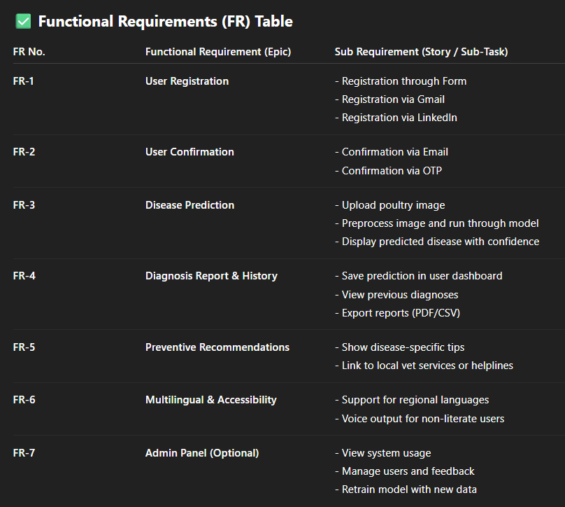

**Non-functional Requirements:**

Following are the non-functional requirements of the proposed solution.

